PT 8633/915

SDI Test Pattern Generator

Supplement to: PT 5300 Reference: Manual no. 9499 491 02811

The supplement describes the modifications made to the standard instrument.
Modification of PT 8633
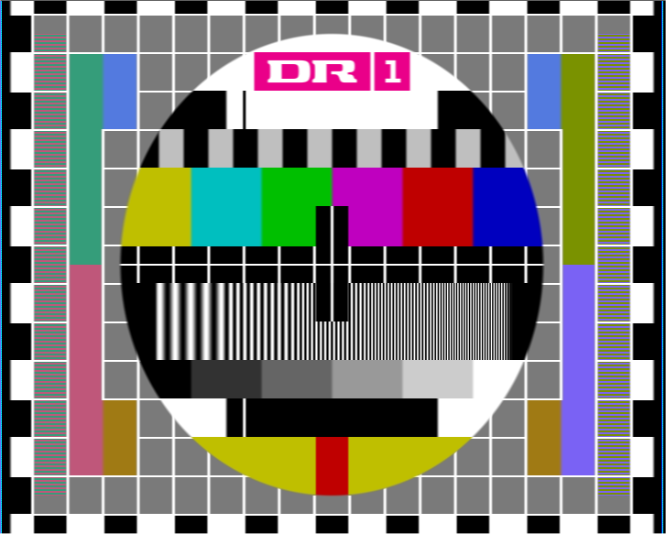
The Philips pattern, 4:3, 625 lines, together with Philips pattern 16:9, have been modified with the logo as described in picture files supplied by Danmarks Radio.

The one logo part of the picture have been shaped to give a reasonable video bandwidth. The resolution has been changed to fit the resolution in the generator.

Plot of the modified data stored in PROM’s

PT 8633/915
New PROMs installed.

Position: | Code number | Checksum

V69 4008 119 60101 9C81
V86 4008 119 60102 D71F
V87 4008 119 60103 25F1
V88 4008 119 60104 6908

Please refer to drawing below for position of IC’s

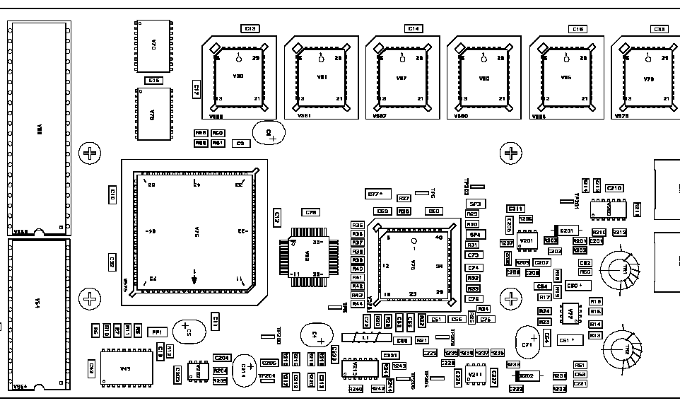
V69
V88
V87
V86

